Appendix A: Application Questions - Request for Proposals 229

This Appendix includes the questions that will be asked in the application to OEWD Request for Proposals (RFP) #229. You may draft your responses on this template, but please enter your responses into the online application by the deadline, Thursday, May 16, 2024 by 5:00 P.M.
To access the online application, visit the following website and click on the RFP 229 page:
https://sf.gov/information/bid-opportunities

Please do not upload this Appendix with your application. Please make sure you upload all required attachments listed on the Proposal Package Checklist found at the end of this document. If you have any questions about the content of this appendix, OEWD is here to help! Please join one of our optional technical assistance sessions or submit questions to oewd.procurement@sfgov.org
PART I. APPLICANT PROFILE
In this section, provide all organizational contact information. Note that if you are a fiscal sponsor or fiscal agent, you will need to complete an applicant profile for both your organization (“Primary Applicant”) and your subgrantee (“Program Lead”).
- The Primary Applicant is the organization or firm that will hold the contractual obligation with the City.
- If you are applying as the fiscal sponsor or fiscal agent for another entity, your application must also identify a Program Lead, which is the primary entity delivering services.

Information requested in the Applicant Profile section includes:
- Organization name (Name as listed in the California Secretary of State Registry)
- Address, website and main phone number
- Executive Director name, contact information
- Proposal point of contact name, contact information
- Type of organization (Nonprofit, for-profit corporation/LLC, individual sole proprietor, etc.)
- Supplier (City vendor) or Bidder Status
- Employer Identification Number (EIN), also known as your agency’s tax ID, as registered with the Internal Revenue Service
- Your current Organizational Chart (“Org Chart”)
- Information on your Executive Director/CEO’s tenure
- Information on your staff (full time equivalent employees, number of volunteers)
- Information about your Board of Directors (see details below)
- Information on additional organizations involved in delivering the program
- Information on your overall organizational budget (data entry field and file upload)
- Program area in RFP 229 you are applying to
Responsibilities of Fiscal Sponsors and Fiscal Agents
As noted in the RFP, to receive a grant under this Solicitation, Proposer must be in good standing with the California Secretary of State, the Franchise Tax Board and the Internal Revenue Service. If Proposer is a nonprofit organization, it must also be in good standing with the California Attorney General’s Registry of Charitable Trusts. Proposer cannot be suspended or debarred by the City or any other governmental agency. Proposer must comply with all applicable legal requirements by the time of grant execution and must remain in good standing with these requirements during the term of the agreement. Upon request, Proposer must provide documentation to the City demonstrating its good standing with applicable legal requirements. If Proposer will use any subcontractors/ subgrantees/ subrecipients to perform the agreement, Proposer will be responsible for ensuring they are also in compliance with all applicable legal requirements at the time of grant execution and for the duration of the agreement.
If you are a fiscal sponsor to another organization (or group of organizations), you must serve as the lead applicant and meet all criteria described above. While your subcontractors/ subgrantees/ subrecipients do not need to become City Suppliers, they must meet all other applicable compliance requirements.
Should a fiscal sponsorship relationship terminate during the course of the agreement, OEWD will require documentation that proves that the new lead entity (which may be an approved subgrantee or a new fiscal sponsor) can meet all of the initial award criteria, and can accept the terms of the remaining agreement. In the event that a new qualified fiscal sponsor cannot be identified, OEWD reserves the right to cancel the award and terminate the agreement.
Please note: The City reserves the right to decline to enter into a contract due to the failure of a nonprofit organization to be eligible to do business as a result of its non-compliance with the requirements of a governmental agency having jurisdiction, including, but not limited to, the organization’s failure to be in good standing with the California Registry of Charitable Trusts.

Staffing and Board information.
Your application requires basic information about your staff and board. These questions should be answered for the Primary Applicant and, if that entity is applying solely as the fiscal agent to another legal entity, we will also need Staffing and Board information for the Program Lead. This information will not be required for fiscally sponsored projects (program leads that are not legal entities).
STAFFING AND BOARD COMPOSITION CHART
Executive Director Tenure  How many years (or months, if under one year) has your Executive Director/CEO been in this role? | Enter your Executive Director/CEO/President’s tenure in years/months.
Total Number of Full Time Equivalent (FTE) Employees | Provide the FTE number for the whole organization, not just the program being proposed.
Number of Governing Board Members
Exclude Advisory/Emeritus members.
List of Current Board Members
The Board of Directors should include San Francisco residents and/or members with knowledge of the needs of low and moderate income San Franciscans from the target neighborhoods/populations described in the RFP. Fiscal sponsors should only list governing Board members; Program Lead organizations can list Advisory Board members, if applicable.
Name | Years (or months) on Board | Home Neighborhood* | Job or Relevant Experience**

*If the Board Member lives outside of San Francisco please list the city and state.
**Job or relevant experience can include lived experience, neighborhood knowledge and demographic information as well as professional experience.
If you are in the process of recruiting new Board members, please describe your efforts to ensure a diverse and equitable board that aligns with the community being served.
(Limit: 1,000 characters)
Total Number of Volunteers  Please exclude Board members that have been counted above. | [Volunteers]

PART II. PROJECT DESCRIPTION
In preparing your proposal, please address all questions in response to the scope of work. Pay particular attention to and address in full; minimum qualifications, preferred qualifications, and any program area-specific questions. Proposals are evaluated based on clarity, substance and measurable results. Note: Character limits include spaces.

Please select a program area, indicate the Project Title, provide a brief (1-2 sentence) summary of the Project, and select the neighborhood(s) you are targeting.

Introduction | Character Limit | Point value
Project Title | 100 characters | N/A
Please provide a brief 1-2 sentence summary of the proposed project. | 350 characters | N/A
Target Neighborhood(s) | Select from the available options and indicate any additional target neighborhoods you may be focusing on | N/A

Section 1 | Point Value
Applicant Qualifications and Staff Assignments | 30 points

This section should briefly address the principal objectives of the proposed project, and establish the applicant’s professional qualifications and the experience of proposed partners, sub-contractors and staff. The applicant should detail past experience and track record implementing projects similar to the proposed activities. Details may include how staff will be accessible and available to individuals and/or organizations receiving services, the relevant experience of staff members, and the distribution of workload within the project team. This section should further note how the project team demonstrates a thorough understanding of the economic, social, financial, institutional or other issues that require a solution as well as indicators of community support.

Specific questions in this area:

- Briefly describe your organization’s mission, values, and history providing services to residents and businesses in San Francisco. (Limit: 2,000 characters)
- Describe any past experience successfully implementing similar projects or activities, including grants or contracts with the City of San Francisco or other funders. You may include details on active/ongoing projects as well as prior/completed projects. Please be sure to highlight successful outcomes for the target populations or neighborhoods in the program area. (Limit: 3,000 characters)
- Describe your staffing plan for the proposed project (Limit: 4,000 characters). Please answer all of the following in this section:
  - List the names, titles and qualifications of staff, partners, and subcontractors that will make up the project team. If you do not have a person identified yet (e.g. if you have a vacant position), please provide information on the status of the hiring process.
  - How will work be distributed within the project team?
  - Are there any specific cultural, linguistic, educational or other skills that will help the project team deliver the proposed project?
- Describe the target populations you primarily serve, your experience serving them, and key needs you hope to address with this funding. (Limit: 4,000 characters). Highlight the economic, social, financial, institutional or other issues that require a solution. Please also share any work you have done with the relevant communities to confirm that this proposed project is appropriate and necessary. Examples may include:
- Surveys or focus groups with community members
- Organizing or advocacy efforts with community members
- Research or review of data and best practices serving the target populations

Section 2 | Point Value
Approach, Activities and Outcomes | 50 points

This section should outline a plan of action that describes in sufficient detail the specific scope of services applicant(s) propose and how the proposed work will be accomplished. The plan should address all functions and activities for which applicants seek funds. Cite factors that might accelerate or decelerate work, explain rationales for strategies selected, and describe any unique or unusual features of the proposed project, such as design or technological innovations, cost or time saving strategies, or methods to increase engagement of targeted stakeholders in services. Include and make clear the organizations, cooperating entities, consultants or key individuals who will work on the proposed activities, with a brief description of their contributions and qualifications. For Program Areas with Supplementary Questions please address them in this section, unless otherwise noted.
- Clearly state your approach to the project. (Limit: 4,000 characters). Provide detailed goals and objectives, and describe any evidence-based practices that inform your project design.
- Describe the services to be provided. (Limit: 4,000 characters) For each service component, provide detail on the following, as appropriate: types of activities; number of hours; frequency of services; location(s) of services; and methods that will be used to deliver services.
- Describe the qualitative and quantitative outcomes your project proposes to achieve. (Limit: 3,000 characters). Provide projections of the accomplishments to be achieved for each activity or function proposed, such as the number of activities or steps to be accomplished or number of individuals or businesses to be served. If accomplishments cannot be quantified, list them in chronological order to show a sequence of steps and their projected start and end dates.
- Provide a project timeline. (Limit: 4,000 characters) Please include all major milestones and target dates, as appropriate. Describe any factors that might speed or hinder implementation of the project, and explain how you will manage unanticipated project hurdles, should they arise.
- Describe your expertise serving demographic and geographical areas of focus where appropriate, or as required by the program area. (Limit: 2,000 characters) Describe specific outreach or engagement strategies that you will use to reach target populations identified in the RFP.
- If required, please respond to any additional Supplementary Questions and Attachments as required by the Program Area. (Limit: 3,000 characters for each question, with upload buttons to match the number of files required)

Section 3 | Character Limit | Point Value
Performance Measurement and Reporting | 6,000 characters | 10 points

For this section, provide a narrative – limited to 6,000 characters – describing the following:

- How data on project activities and outcomes will be collected and reported.
- Measures that will be developed and/or used to determine the extent to which the project has achieved its stated objectives
- How data will be used to determine whether the needs identified are being met and whether project results are being achieved
- Any processes and procedures that are or will be in place to determine whether the project is being conducted in a manner consistent with the work plan and how effectiveness and efficiency will be improved
- How the outcomes proposed and measured will demonstrate positive impact based on the Scope of Work outlined within the program area.

Section 4 | Character Limit | Point Value
Financial Management and Budget | 6,000 characters | 10 points

Please provide a brief narrative – limited to 6,000 characters – detailing the financial management of the Primary Applicant organization. In this section, you should respond to the following, as applicable:

- Describe the key features of your organization’s financial tracking system and confirm it is capable of generating all financial information needed for required reports, including data needed to monitor, evaluate and if necessary, modify program performance.
- Describe in detail any cost allocation plan utilized when costs are chargeable to more than one cost category, or to more than one program and/or funding source.
- If proposing a management fee/fiscal fee, identify the amount as well as how the requested percentage was identified.
- Provide a narrative justification for items in the budget. Note, if the program area you are applying to includes the possibility of a multi-year grant award, please share any major budget changes (above 10% for any individual line item) that you expect to incur in future program years.
- Provide details on any matching or leveraged funds including anticipated source, amount, and restrictions. Although not required, matching funds are encouraged for all program areas.

Note: in addition to your written narrative (limited to 6,000 characters), make sure to upload a proposed budget for the project using the budget template available on the RFP 229 website (“Appendix B”).

Proposal Package Checklist
The following items must be completed and included in the application package.
☐ Appendix B, Proposed Budget template – Please list your proposed project budget on this template and upload it where prompted before you submit your application.
Additional required attachments:
☐ Organizational Budget (no template) – Overall organizational budget for the Primary Applicant and Program Lead, if applicable (no template provided). Please upload organizational budget(s) where prompted before you submit your application.
☐ Organizational Chart (no template) – Organizational chart for the Primary Applicant and Program Lead, if applicable (no template provided). Please upload organizational chart(s) where prompted before you submit your application.
☐ Supplementary Attachments – Reference whether Supplementary Attachments are requested for the Program Area(s) to which your organization is responding and include those items in the Proposal Package submission. Note that some areas require items such as letters of support or MOUs.

Submitting your Proposal

When you have completed your proposal, please make sure to click “Submit” on the final screen.
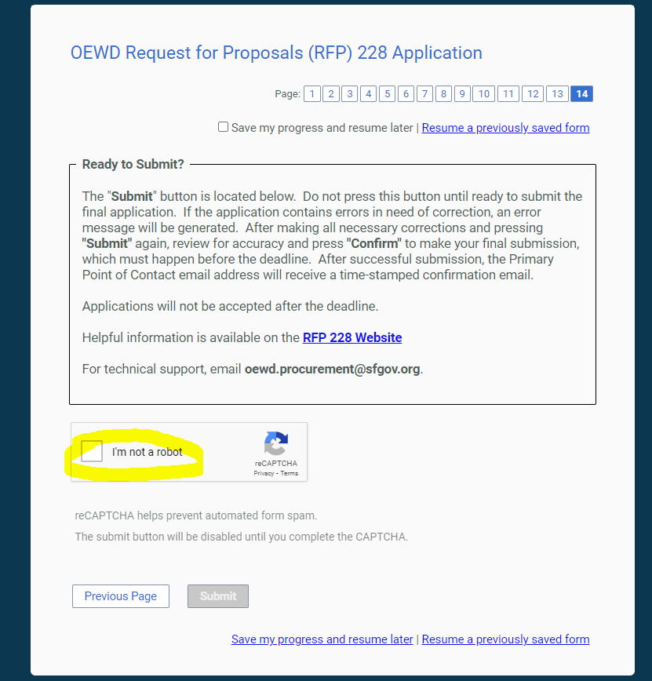

You will receive an error notification pop-up message if any corrections need to be made before your proposal is accepted. If an error exists, the system will flag the page(s) in the application with errors, and provide a description of the issue(s). Please pay attention to the page numbers in the top-right side of your screen; if there are additional errors on any pages in your application, those pages will be highlighted in red:

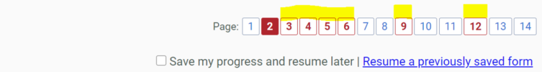

After making all necessary corrections and pressing “Submit” again, you will be able to review your application and confirm that it is accurate and complete. You can also print your submission for your records.

After reviewing your submission, press “Confirm” in the bottom-left corner of the screen to make your final submission, which must occur before the deadline. The system locks out at the deadline, when confirmation and submission will no longer be possible. After you click “Confirm”, the application will be locked. After successful submission, you will see a confirmation screen, and the Primary Point of Contact Email Address that you listed in your application will receive a time-stamped confirmation email within about five minutes.

You may follow up with OEWD at oewd.procurement@sfgov.org if you have any questions or need technical assistance with your submission. If you have submitted a proposal in error and need to re-file your proposal, please contact oewd.procurement@sfgov.org and let us know which proposal should be considered.

