Overriding Modifier Information Sheet
For SMHS Outpatient Providers

Under Payment Reform, the following outpatient service modifiers are used when billing Short Doyle Medi-Cal (SDMC) for outpatient services when one or more than one service is provided to the same client on the same day.

- 27- multiple outpatient hospital evaluation and management encounters on the same date
- 59 - distinct procedural service
- XE – separate encounter
- XP - separate practitioner
- XU – unusual non-overlapping service

Modifiers XE, XP, and XU give greater reporting specificity in situations where you may have used modifier 59 previously. Use these modifiers instead of modifier 59 whenever possible. Additional information about the appropriate and inappropriate use of these modifiers can be found here. Please note, the modifier HE is no longer required for outpatient programs.

Providers enter the appropriate modifier(s) in the “Edit Service Information” form in Avatar which overrides the established system crosswalk. Therefore, additional modifiers may be required to accurately bill SDMC for services rendered by certain types of staff, in certain service locations setting, or over the telephone or telehealth.

To assist in this effort, BHS has created a tool to assist outpatient SMHS providers in choosing the appropriate modifier(s) for billing overridable lockouts under Payment Reform.

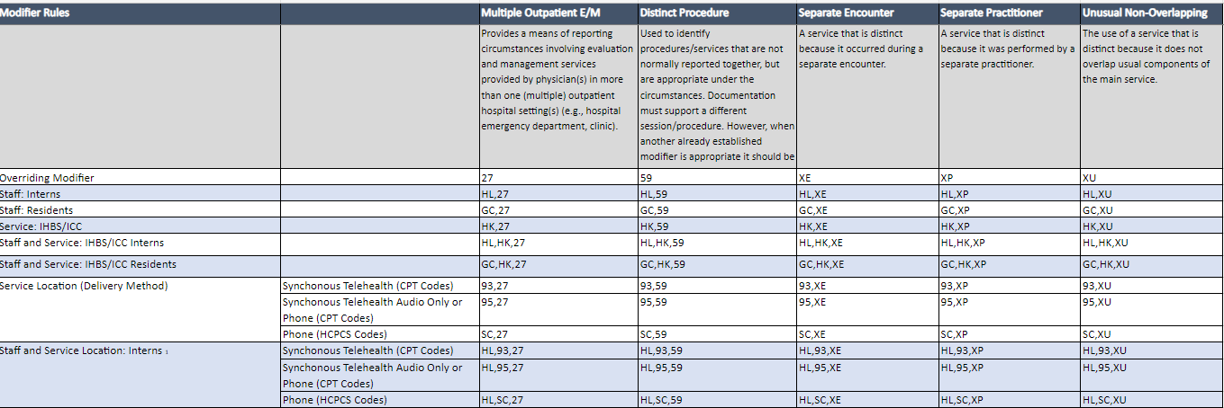

Instructions on how run add Modifier(s) via “Edit Service Information” form can be found below.

- Go to “Edit Service Information” form in Avatar.
- Enter the Client ID or Client Lastname,Firstname
- Select the Correct Episode Number and click the ‘Select Service(s) to Edit’ button.
- Choose the Service Date and add the appropriate Modifier(s) from the modifier tool. Click Submit.
Note: Providers must
  - Use Upper Case Letters for Modifier(s)
  - Enter a Comma to separate Modifier(s)
  - Exclude Spaces in between or after each Modifier
- Once the modifiers(s) have been entered, please re-run required report(s) to review information.

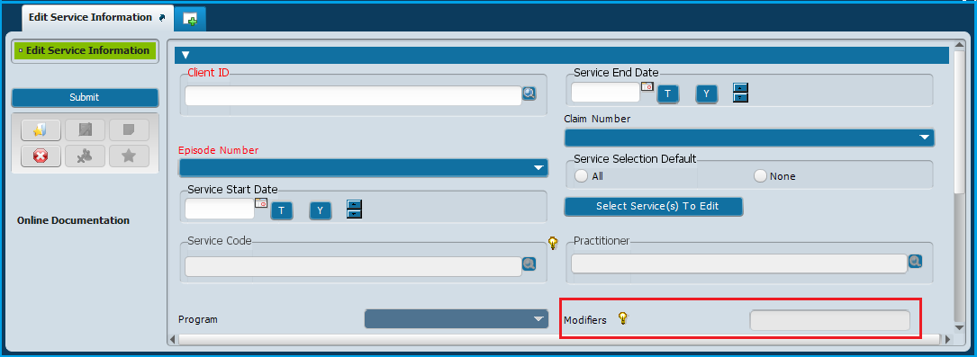

Need Additional Support?
CPT/HCPCS Code Crosswalks: https://sf.gov/resource/2023/provider-billing-documentation-library
SMHS Billing Manual: https://www.dhcs.ca.gov/services/MH/Pages/MedCCC-Library.aspx
Billing Specific Questions: Microsoft Forms
All other CalAIM Questions: bhscalaim@sfdph.org

