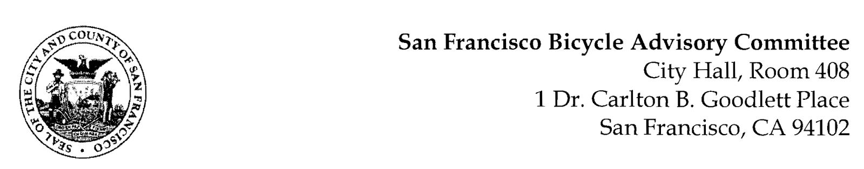

https://www.facebook.com/events/931529371184231
MEETING AGENDA
Monday, February 27, 2023 at 6:30pm
Members: District 1 – Ms. Kristin Tieche- (Vice Chair), District 2 – Whitney Ericson, District 3 – Mr. Marc Brandt, District 4 – Open, District 5 - Ms. Melyssa Mendoza (Secretary), District 6 – Ms. Mary Kay Chin, District 7 – Mr. Bert Hill (Chair), District 8 – Ms. Diane Serafini, District 9 – Brandon Powell, District 10 – Mr. Paul Wells, District 11 – Mr. Jeffrey Taliaferro
ORDER OF BUSINESS
- Roll Call – Determination of Quorum
- Ramaytush Ohlone Land Acknowledgement
- Approve Minutes – Monday, January 23, 2022
- Public Comment (Discussion Item)
The public may address the Committee on any matter within the jurisdiction of the Committee. This should not relate to any item on this agenda since the Committee will take public comment after it discusses and/or before voting on each agenda item. The Committee requests that each person limit themselves to three minutes.
- Committee Reports & Administrative Business (Information)
  - Chairman's Report
  - District Committee Member Reports
- Governmental/Organizational/Committee Reports (Discussion Item)
  - MTA Bicycle Program Report – Eillie Anzilotti
  - CTA Bicycle Project Funding – Aprile Smith
  - SF Bicycle Coalition – Rachel Clyde
  - SF Public Works -
  - BART Bicycle Advisory Task Force –Jon Spangler

- 13th Street Safety Project - (Resolution) Jennifer Wong & Joel Goldberg, Streets Division, SFMTA TDA Article 3 Request – This is a proposal to improve traffic safety and comfort for all who travel on the 13th Street corridor. Specifically, it will reduce the number of conflicts between those who walk, bike, and operate motor vehicles along this corridor. It will also increase the connectivity of San Francisco’s bicycle network.
- Support of the SFMTA Safe Routes to BART Grant Application – (Resolution) Julia Malmo, MTA. This is a resolution in support of funding for Safe Streets in Glen Park bordering the BART Station.

- Adjournment

