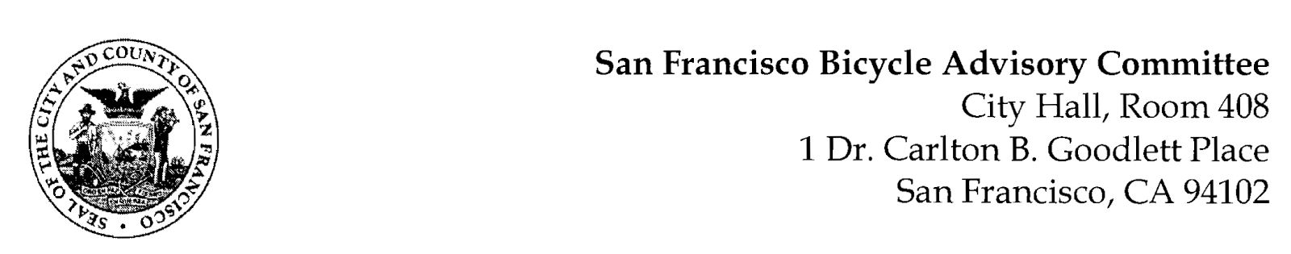

https://www.facebook.com/events/804052484278678/

MEETING AGENDA
Monday, August 22, 2022
Members: District 1 – Ms. Kristin Tieche- (Vice Chair), District 2 – Ms. Sarah Boudreau , District 3 – Mr. Marc Brandt, District 4 – Ms. Jina Bartholomew, District 5 - Ms. Melyssa Mendoza (Secretary), District 6 – Ms. Mary Kay Chin, District 7 – Mr. Bert Hill (Chair), District 8 – Ms. Diane Serafini, District 9 – Brandon Powell, District 10 – Mr. Paul Wells, District 11 – Mr. Jeffrey Taliaferro

ORDER OF BUSINESS
- Roll Call – Determination of Quorum
- Ramaytush Ohlone Land Acknowledgement
- Approve Minutes – Monday, July 25, 2022
- Public Comment (Discussion Item)
The public may address the Committee on any matter within the jurisdiction of the Committee. This should not relate to any item on this agenda since the Committee will take public comment after it discusses and/or before voting on each agenda item. The Committee requests that each person limit him/herself to three minutes
- Committee Reports & Administrative Business (Information)
  - Chairman's Report
  - District Committee Member Reports
- Governmental/Organizational/Committee Reports (Discussion Item)
  - MTA Bicycle Program Report – Victoria (Brian Liang and/or Kimberly Leung – Valencia Status))
  - SF Bicycle Coalition – Rachel Clyde (?)
  - SFPD Traffic Division – Open
  - Public Works - Open
  - BART Bicycle Advisory Task Force –Jon Spangler
  - Bay Wheels – Neal Patel (No Report)
- Battery/Sansome Quick-Build Project (Presentation) Victoria Chong – The project aims to bring Northbound and Southbound protected bikeway connection to and from the Financial District.
- Election of SF Bicycle Advisory Committee Officers for a One-Year Term of Office (Election) Melyssa Mendoza
- Adjournment

