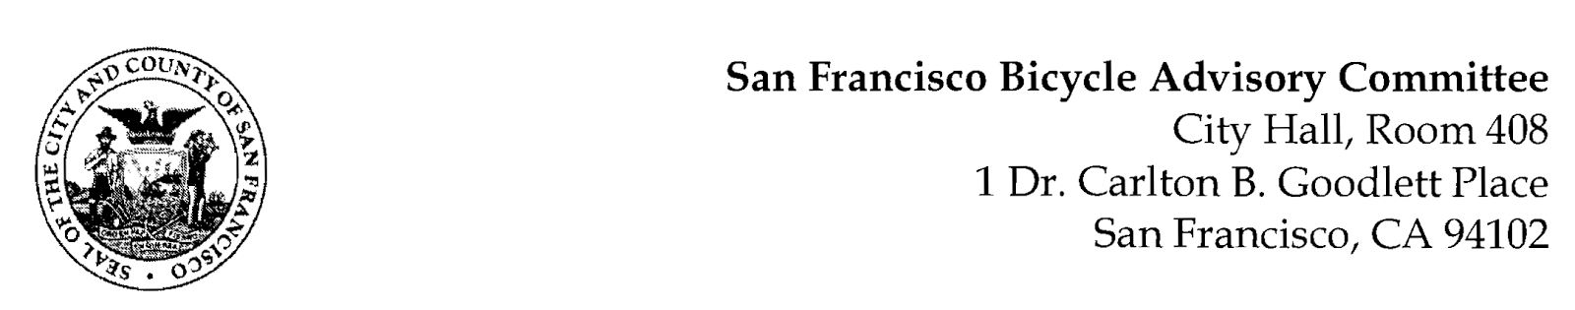

https://www.facebook.com/events/589366239202308

MEETING AGENDA
Monday, June 27, 2022
Members: District 1 – Ms. Kristin Tieche- (Vice Chair), District 2 – Ms. Sarah Boudreau , District 3 – Mr. Marc Brandt, District 4 – Ms. Jina Bartholomew, District 5 - Ms. Melyssa Mendoza (Secretary), District 6 – Ms. Mary Kay Chin, District 7 – Mr. Bert Hill (Chair), District 8 – Ms. Diane Serafini, District 9 – Brandon Powell, District 10 – Mr. Paul Wells, District 11 – Mr. Jeffrey Taliaferro

ORDER OF BUSINESS
- Roll Call – Determination of Quorum
- Ramaytush Ohlone Land Acknowledgement
- Approve Minutes – Monday, May 23, 2022, Monday, June 6, 2022
- Public Comment (Discussion Item)
The public may address the Committee on any matter within the jurisdiction of the Committee. This should not relate to any item on this agenda since the Committee will take public comment after it discusses and/or before voting on each agenda item. The Committee requests that each person limit him/herself to three minutes
- Committee Reports & Administrative Business (Information)
  - Chairman's Report
  - District Committee Member Reports
- Governmental/Organizational/Committee Reports (Discussion Item)
  - MTA Bicycle Program Report – Eillie Anzilotti (she, her)
  - SF Bicycle Coalition – (Open)
  - SFPD Traffic Division – Lt. Bill Conley (Acting Captain) Excused
  - Public Works - Open
  - BART Bicycle Advisory Task Force –Rick Goldman & Tyler Morris
  - Bay Wheels – Neal Patel (No Report)
- Bicycle Parking Facilities (Resolution) Diane Serafini - A resolution advocating for safe and secure parking facilities throughout San Francisco
- Adjournment

