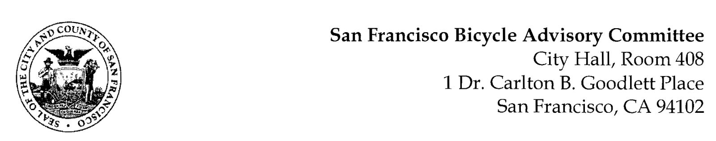

https://www.facebook.com/events/436720824503039

SPECIAL MEETING AGENDA
Monday, June 6, 2022
Members: District 1 – Ms. Kristin Tieche- (Vice Chair), District 2 – Ms. Sarah Boudreau , District 3 – Mr. Marc Brandt, District 4 – Ms. Jina Bartholomew, District 5 - Ms. Melyssa Mendoza (Secretary), District 6 – Ms. Mary Kay Chin, District 7 – Mr. Bert Hill (Chair), District 8 – Ms. Diane Serafini, District 9 – Brandon Powell, District 10 – Mr. Paul Wells, District 11 – Mr. Jeffrey Taliaferro

ORDER OF BUSINESS
- Roll Call – Determination of Quorum
- Ramaytush Ohlone Land Acknowledgement
- Public Comment (Discussion Item)
The public may address the Committee on the agenda items listed below. The Committee requests each person to limit themselves to three minutes.
- Resolution in Support of the MTA Transportation Development Act, Article 3 Request for Fiscal Years 2021-22 and 2022-23 (Resolution)
- Bicycle Parking Modules (Presentation) Diane Serafini - A presentation advocating for equity for safe and secure unattended parking facilities in San Francisco
- Adjournment

